# Lab 04 – Restoring Database and Reverse Engineering

This Lab relates to the following Course Learning Requirements:

CLR 1: Follow lab policies and procedures for etiquette, software licensing requirements and lab submissions.

CLR3: Reverse engineer a database schema to reveal an ERD.

CLR3: Restore a database from a given backup

Objective:

The objective of this lab is to make sure that you have proper knowledge to restore database from backup and reverse engineer database to reveal ERD.

# Pre-Lab Instructions:

1. Read Module 4.

**Lab Tasks:**

1. Go to the MySQL workbench File -> New Query Tab
2. Once you have the diagram screen open. You should connect to the database. Just like lab 03. 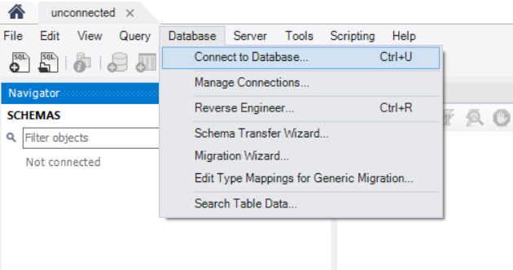
3. Next step is to import the database. Go to Server -> Data Import
4. There are two tabs on the screen:
   * Import from Disk:
     1. Go to import from self-contained file and search for Lab4.sql file.
     2. Next go to default target schema and click new and name the schema car_fuel.

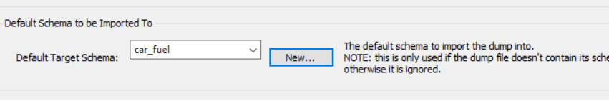

* + Import progress:
    1. Click start import and make sure the import was successful.

1. Now go to the navigator to the left of the WB and click refresh.
2. You will see car_fuel database created with three tables under it.
3. Right click each table and select rows – limit 1000.
4. Take a screenshot snippet of the table data (save screenshots of every table from Step 7 for submission).
5. After you have made sure you have all the tables, we will work on creating the ERD using Reverse Engineering.
6. Click Database -> Reverse Engineer
7. Keep the default setting and click next.
8. Select the car_fuel database and click next.
9. Make sure retrieval is successful
10. Execute the import of three MySQL statements.
11. Click finish.
12. You will see an ERD take a screenshot (save this screenshot for submission).
13. Your lab is to be submitted in MS WORD format. It should be submitted with the following guidelines:
    * On the header have the course code and course name, the lab number, your student ID, your name, the instructor’s name, and the date the lab is submitted.
    * Paste the screenshot on the word document from Step 8 and Step 16

**Lab Grading Rubric (3%)**

|  |  |
| --- | --- |
| Lab Submission (Correct screenshot attached to the word document) | /1 |
| Importing the database successfully | /1 |
| Lab Structure (Submission guidelines) | /1 |
| Total Points | /3 |
| Comments |  |

**References**

**The dataset used in this lab is taken from the below resource:**

Open Government. (n.d.). Fuel consumption ratings. Retrieved from <https://open.canada.ca/data/en/dataset/98f1a129-f628-4ce4-b24d-6f16bf24dd64>

Contains information licensed under the Open Government Licence – Canada ( <https://open.canada.ca/en/open-government-licence-canada> )